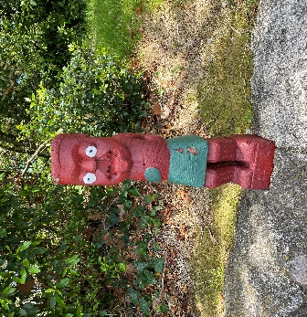
NEW ZEALAND
Aotearoa – Land of the Long White Cloud
February 22 – March 7, 2023

“It’s Summer Down Under!”
Personally hosted by Larry & Cathy Gelwix
100% Pure New Zealand stirs our imagination with adventure, alpine mountain splendor that rivals the Swiss Alps, the land of Lord of the Rings, hobbits, and Middle Earth, varied landscapes of sweeping valleys, snow capped peaks, thermal geysers, lakes and streams, spectacular fjords, glaciers, volcanoes, rugged coastlines, South Pacific islands, indigenous Maori natives, and the friendliest people on earth! This is New Zealand!
DATE | ITINERARY
Feb. 22 | Depart USA.
Feb. 24 | Arrive Auckland. Great downtown hotel.
Feb. 25 | “Best of Both Worlds” tour of Auckland & “Wilderness Experience”
Feb. 26 | Auckland, Waitomo, & Cambridge
Feb. 27 | Rotorua via Matamata & Hobbiton Movie Set Tour
Feb. 28 | Rotorua tour, Rainbow Springs, Te Puia Maori Village, & Maori concert & dinner
March 1 | Fly to Queenstown on the South Island
March 2 | Queenstown tour, Walter Peak cruise, Lake Wakatipu, Skyline Gondola
March 3 | Full-day Milford Sound adventure
March 4 | Free day in exciting Queenstown
March 5 | Queenstown to Franz Josef along NZ’s alpine west coast splendor
March 6 | Franz Josef Glacier & Franz Josef to Christchurch via the TranzAlpine train
March 7 | Free time in Christchurch. Depart Christchurch to USA. Arrive home same day.
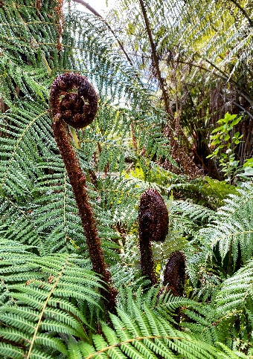
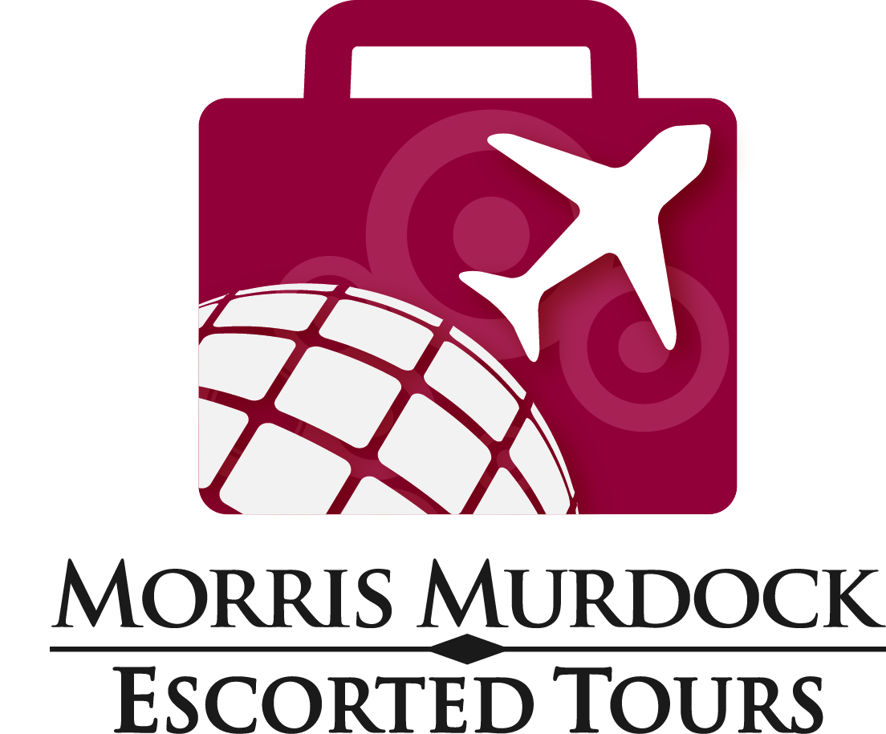
Full tour details online at MMETOURS.COM
Call your favorite Morris Columbus Travel Advisor or our Group Depart at 800-809-9910 to ask questions
or make your reservation today

RESERVATION INFORMATION

Land Tour Costs:
- $3,695 per person based upon double occupancy (Single Supplement: + $1,295)
- Tour rates are based upon current New Zealand dollar and US dollar exchange rates and are, therefore, subject to change.

Airfare costs: Airlines publish their schedules and fares 11 months in advance of round-trip travel dates. We will have discount airfares available late February/early March.
LAND TOUR DEPOSIT: $500 per person FINAL PAYMENT: October 7, 2022

What is Included:

- First Class hotel/resort accommodations
- Comprehensive sightseeing as per itinerary including admission and entrance fees
- Most meals as listed (B: breakfast, L: lunch, D: dinner)

Cancellation Policy:
- Free cancellation up to 7 days from deposit
- After 7 days there is a 50% cancellation fee of your deposit or full transfer to future cruise credit
- Cruise tour is fully non-refundable after final payment

Health and Safety Commitment: If any of our tours/cruises are cancelled due to health or safety reasons we offer options for rebooking, future travel credits or refunds based on each product and destination, please ask for more details.

- Deluxe motorcoach with commentary on transfers and touring
- Local guides to assist
- Larry & Cathy Gelwix serve as your tour hosts

What is Not Included:

- International and domestic airfare
- Anything not listed as “Included”
- Anything of purely a personal nature
- Drinks with meals
- Guide and driver tips and gratuities

INTERNATIONAL TRIPS: For all tours and cruises that include international air, a valid passport is required and must be valid for at least 6 months beyond date of entry and one blank page per stamp. Columbus Travel must receive a copy of your passport information page at least 90 days before the departure date. Airlines have strict policies concerning name changes/corrections after tickets have been issued. If a name change/correction is required on your ticket, you will be required to cover the cost of the fees.
Morris Murdock Escorted Tours &
Morris Columbus Travel
101 South 200 East, Suite 1B/Salt Lake City, UT 84111
Mmetours.com – MorrisColumbus.com
groups@morrismurdock,com
800-809-9910 and 800-944-8018

FULL terms and conditions are provided on all booking
COVID-19 WAIVER and TERMS: By signing up for any tour I am agreeing to abide by all COVID-19 protocols while on tour as defined by the host country or business, which may include being fully vaccinated with booster, wearing a mask and producing proof of vaccination or negative test for COVID-19 prior to arrival. I understand that if I and/or my party does not follow all set protocols, it is grounds for removal from tour or specific tour activities.
INTERNATIONAL TRIPS: For all tours and cruises that include international air, a valid passport is required and must be valid for at least 6 months from the return date of the trip. Morris Murdock Escorted Tours must receive a copy of your passport information page by final payment date. Airlines have strict policies concerning name changes/corrections after tickets have been issued. If a name change/correction is required on your ticket, you will be required to cover the cost of any fees.
TERMS AND CONDITIONS: Morris Columbus/Morris Murdock Escorted Tours, ("Agent") gives notice that all services, reservations and arrangements for transportation, cruise, conveyance, hotel or lodging of any type, meals, sightseeing services, or any other activities made by Agent, are made by Agent as dual agent for the traveler/passenger and for the air carriers, hotels, sightseeing companies, transportation companies, cruise lines, and other companies (Suppliers) providing services for this program. As such, Agent shall not be liable for injury, damage, loss, accident, delay, or irregularity which may be occasioned either by reasons of defect in any vehicle or mode of transportation, through the acts, defaults, financial difficulty, bankruptcy, or omissions of the Supplier or person engaged in carrying out the arrangements of the trip or otherwise in connection therewith. Agent is not liable for delays and/or cancellations of services and resultant expenses or loss caused by acts of God, weather, disaster, government regulations, sickness or death, quarantine, strikes, war, terrorism, social or labor unrest, local laws, mechanical or construction difficulties, curtailment or disruption of transportation, abnormal conditions or other situations, actions, omissions or conditions outside Agent's control. Agent is not liable for loss of, or damage to, baggage or personal possessions. Agent and Supplier reserve the right to alter or cancel the itinerary or substitute services as conditions require or for the safety of traveler/passenger. Passengers must be in good health and able to care for their own needs. Please contact us regarding any health concerns you may have or if you need to bring any specialized medical equipment such as wheelchairs, oxygen tanks, C-Pap, etc. so that we can determine if Supplier can accommodate your equipment. Tour directors on the trip cannot be of assistance with such needs. We reserve the right to remove travelers/passengers from the group at their own expense if the care of or actions of a traveler/passenger become detrimental to the functioning of the tour. Payment of deposit(s) as outlined in this agreement shall be deemed consent to be bound by the terms and conditions of this agreement. Airline schedule changes, mechanical or weather delays may affect flight times. Your connecting flights and/or transportation to and from the tour start and end point, whether issued by Morris Columbus Travel/Morris Murdock Escorted Tours or on your own arrangement, may be affected. Morris Columbus Travel/Morris Murdock Escorted Tours is not responsible for misconnections, delays, and/or cancellations.

Summer Time Down Under
Feb 22 USA – Auckland, New Zealand. Evening departure from West Coast. Crossing the International Date Line, we “lose” a day. (Sorry if Jan. 11 is your birthday!)

Feb 24 Arrive Auckland. Morning arrival in Auckland. We are met by a local guide and transfer to our hotel, perfectly situated in the heart of Auckland and near the harbour, shopping, and dining. Balance of the day free to rest and explore. Orientation get together later today. (Remember, the seasons are reversed south of the equator and it’s the middle of summer Down Under in New Zealand and the South Pacific!) Overnight Auckland. (In-flight meals)

Feb 25 “Best of Both Worlds” tour. Today is really fun! This morning we see the best sights of Auckland city combined with an afternoon “Wilderness Experience”. Auckland is set on 52 dormant volcano cones and between two harbours, the Waitemata and Manukau. Known as the “City of Sails”, Auckland is New Zealand’s largest and busiest city. The morning city tour is a journey of discovery to explore the history and sights of this great world-class city.

A scenic drive brings us to the Arataki Centre, the gateway to the rainforest with breathtaking panoramic views from the Tasman Sea to the South Pacific Ocean. We head further west and explore the wild and rugged west coast, including the famous Black Sand Beach along one of the most awe-inspiring beaches in the world. Your eco-tour continues with our knowledgeable guides taking us into the lush rainforest. An easy bush walk will invite us to hear native birdsong and walk among the kauri trees and giant fern trees. Return to Auckland. Evening free. Overnight Auckland. (B, L)

Feb 26 Auckland – Waitomo – Cambridge. After breakfast we drive south to Waitomo passing through the beautiful countryside of the Waikato and King country. At Waitomo, you will experience the world-famous Glowworm Caves, including a boat ride via an underground river stream. Following a BBQ lunch, we continue to Cambridge where we are met by our local farm hosts. One of the highlights of our tour is an overnight country farm stay which offers a unique opportunity to enjoy the hospitality of friendly New Zealanders in the comfort on their homes. (No worries, you will have private accommodations). You will meet people anxious to share their home, their working farm lifestyle, and themselves, with you. (This is “Trust Larry Time,” this experience is a rich and memorable experience, with lifetime memories, and new kiwi friends!) Farm stay overnight. (B, L, D)

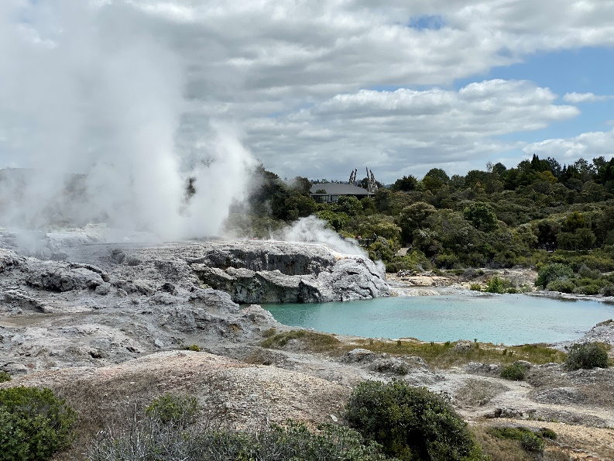
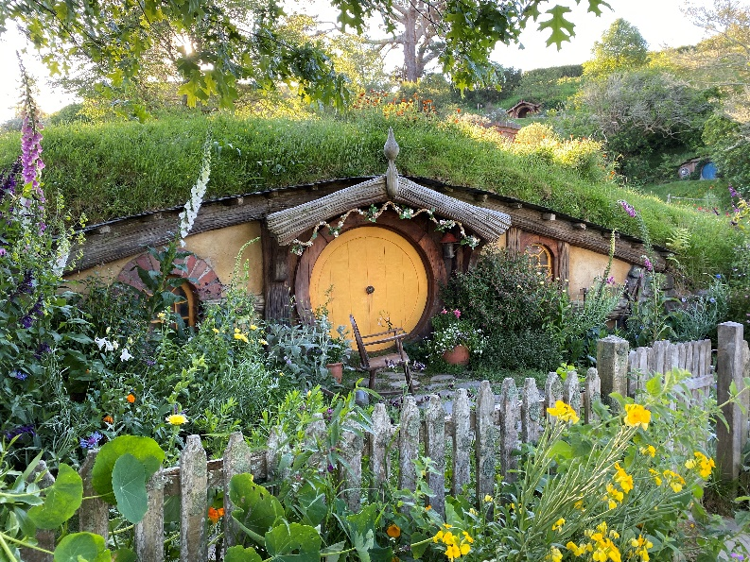
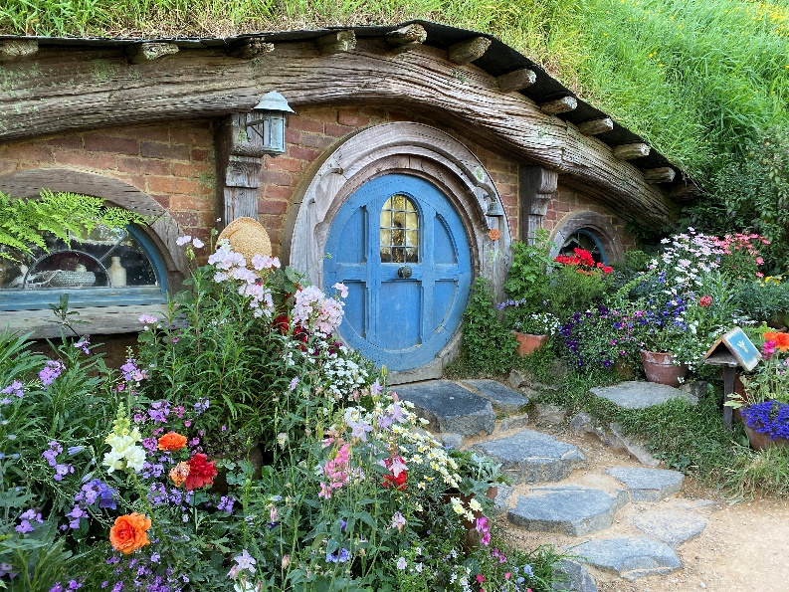
Feb 27 Cambridge – Matamata – Lord of the Rings – The Hobbit & Middle Earth – Rotorua. After breakfast at the farm your hosts will return you to Cambridge. We transfer to Matamata for a one-of-a-kind Hobbiton Movie Set Tour. You will experience the real Middle-Earth, the bucolic setting for The Shire™ featured in The Lord of the Rings and The Hobbit Trilogies movies. Our tour starts with a drive from The Shire’s Rest™ and continues through the 1,250-acre sheep farm with spectacular views across to the Kaimai Ranges. You will visit the 12-acre site recounting fascinating details of how the Hobbiton movie set was created. The Hobbit Holes, Green Dragon™ Inn, and other structures from the films and you will see how this beautiful piece of Waikato farmland was transformed into The Shire from Middle Earth! Nothing like it anywhere else in the world! We now continue on to Rotorua, the center of the Maori natives and culture. Overnight Rotorua. (B, L)
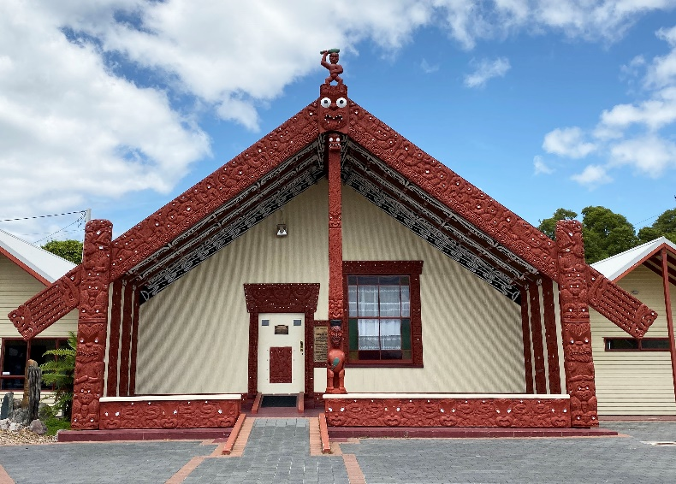
Feb 28 Rotorua. This morning we visit Rainbow Springs set on 22-acres of beautiful native trees, rivers, and streams. Rainbow Springs is home to a wide variety of animal life. Enjoy walking through the many aviaries, feed the biggest wild trout you will ever see, and come face to face with a Tautara, a living reptile only native to New Zealand and regarded as a “living fossil” whose closest relatives are an extinct group of reptiles from the time of the dinosaurs. We are privileged to enjoy a “Behind the Scenes of Kiwi Encounter.” We continue on to Te Puia Maori Village, New Zealand’s 60-hectare living Maori cultural center, located in the Whakarewarewa Geothermal Valley, is home to the New Zealand Maori Arts and Crafts Institute, a live kiwi enclosure, the world-famous Pohutu Geyser, and more than 500 geothermal wonders. A special lunch cooked in a Nga Wha steam vent (you will pick what you want cooked for your lunch) is included followed by interactive arts, crafts, and wood carving learning sessions with local natives. After lunch we visit the Agrodome that takes us through a fascinating insight to the world of New Zealand agriculture and sheep herding.

Later this afternoon we visit the Tamaki Maori Village for a special combined native music, song, and dance concert and a special Hangi (Maori dinner). Welcome to a world of ancient Maori and proud warriors. Enjoy a night of truly authentic traditional culture and entertainment. The Hangi dinner is cooked the traditional Maori way over hot stones in an earthen oven. Overnight Rotorua. (B, L, D)

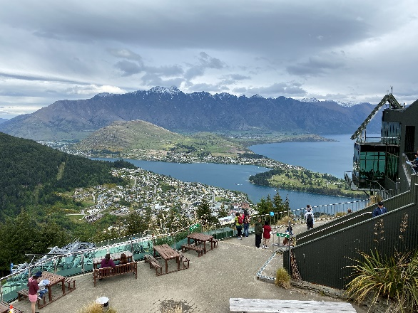
March 1 Rotorua – Queenstown. After breakfast we transfer to the Rotorua Airport leaving the North Island for our flight to Queenstown on the South Island. (from Larry: “Queenstown is one of the most exciting sites in all of New Zealand. I can’t wait to return!”) Transfer to our hotel. Balance of the day free for individual activities with plenty of options available. Overnight Queenstown. (B)

March 2 Queenstown. Today is so much fun! After breakfast we transfer to the “Real Journey Visitor Centre” and check-in for the Walter Peak Cruise. We embark on a scenic cruise from Queenstown Bay across stunning Lake Wakatipu on the TSS Earnslaw, a vintage steamship to the Walter Peak High Country Farm and Gardens. A walking tour takes you to its stately homestead and extensive gardens followed by a BBQ lunch. We re-board the TSS Earnslaw for our return cruise back to Queenstown.

But our day has just begun! Upon our return to Queenstown we make our way to the Observation Point above the town to take in the best panoramic view of the city. We continue on to Coronet Peak to Arrowtown, a quaint, little gold mining village nestled below the mountains. Not done yet! We head back towards Queenstown to board the Skyline Gondola which takes us to Bob’s Peak some 2,600 feet above sea level. You will take the cableway to the top where we enjoy a “Taste of New Zealand” dinner and live entertainment with an unhindered view of the Wakapitu panorama. We return to our hotel after dinner. Overnight Queenstown. (B, L, D)

March 3 Milford Sound. Today will be one of your highlights on a full-day Milford Sound tour. En route we enter a native rainforest, see spectacular waterfalls and glacial lakes with a visit to Te Anau before continuing on the alpine Milford Road. We see incredible views at Eglinton Valley, Mirror Lakes, Knobbs Flat or Monkey Creek before arriving at glacier carved Milford Sound. We sail aboard a catamaran for a nature cruise along the fjord’s deep blue waters. While marveling at the landscape be on the lookout for dolphins, seals, and penguins. We get close to the powerful 15,000-year-old Stirling Falls. Lunch is served onboard. We return to Queenstown with our evening free to explore this favorite city of adventure with a myriad of shops and restaurants available. Overnight Queenstown. (B, L)

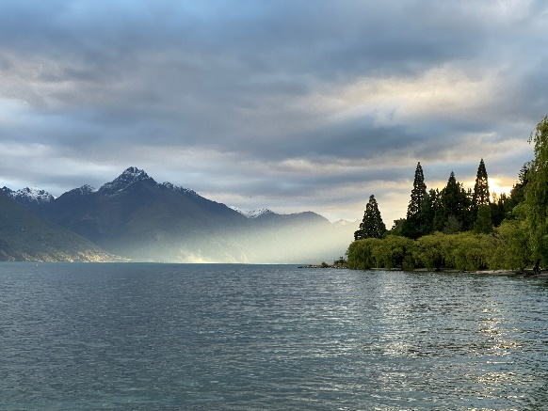
March 4 Queenstown. Today is a free day to kick back and relax or venture out to and join in one or more of Queenstown many optional activities. (from Larry: “Don’t miss the jet boat on the Dart River!”) Overnight Queenstown. (B)

March 5 Queenstown – Franz Josef. After breakfast we drive from Queenstown to Franz Josef taking you through some of New Zealand’s most scenic countryside. The alpine West Coast is regarded by many as one of the most beautiful places on Earth with towering peaks, the deep blue lakes pf Wakatipu, Dunstan, Wanaka, and Hawea; a landscape of vast rainforests and crystal-clear waterfalls. After arrival at Franz Josef we will join our guide along the Glacier Valley Walk. This relaxing, interpretive walk to the glacier takes you through a rainforest and continue up the glacier valley. We later return to our hotel. Overnight Franz Josef. (B, D)

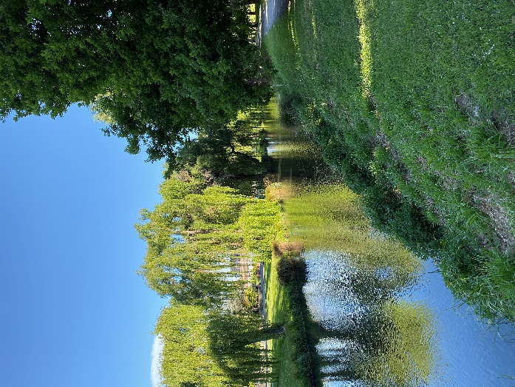
March 6 Franz Josef – Christchurch. Today is spectacular! Our motorcoach will take us to Greymouth where we board our scenic TranzAlpine train to Christchurch. Our train leaves Greymouth on the west coast and travels through lush beech forests passing lakes, mountains, and the rural countryside of the Canterbury Plains before arriving in Christchurch on the east coast. After arrival you will have time to explore the city. Christchurch enjoys a rich English heritage with flat-bottomed “punt” boats gliding along the which meanders through the city center, walking and
cycling paths, the green expanse of Hyde Park, historic buildings and churches, the Christchurch botanic Gardens, and the city’s many shopping and dining venues. Overnight Christchurch. (B, D)

March 7 Christchurch – USA. Where does the time go? Today is our last day in Aotearoa (“land of the long white cloud”, the Maori name for New Zealand). We have time today for last minute shopping and activities. Later today we transfer to the Christchurch Airport for our return flights home with an en route city panoramic tour, or with the help of your Columbus Travel agent extend your stay in New Zealand, Australia, Tahiti, Fiji, or other islands of the South Seas! (B and in-flight meals)

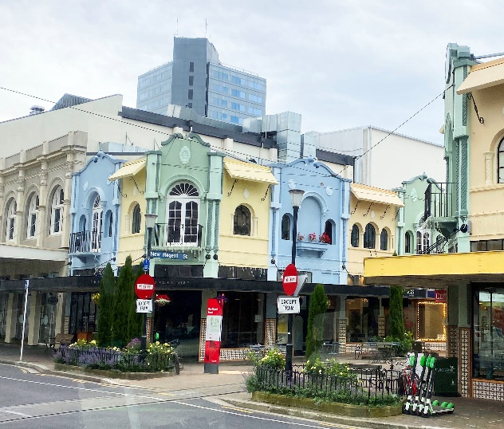
HOW GOOD OF A DEAL IS THIS?
Our “New Zealand” tour is absolutely the best value for a First Class “Down Under” experience. The itinerary is comprehensive including the most scenic and important sites of New Zealand. And remember, south of the equator the seasons are reversed, January is the summer peak season in New Zealand. Compare our program to other similar land only tours, including GoWay Tours “New Zealand Highlights” priced at $5,451; Trafalgar’s “New Zealand Splendour” at $5,361; and Globus’ “Best of New Zealand” at $4,819. You get First Class quality, you see more, and pay less with Columbus Travel!

